|  |  |  |  |  |
| --- | --- | --- | --- | --- |
| ` | | | | |
|  | Visitor Management System  BEUMER Group India Angad Sandhu |  |  |  |

Acknowledgement

I, Angad Sandhu would like to convey my gratitude to the Management, Director, Dean and Career Development Center of MIT Institute for Higher Education, Manipal for emphasizing on the month-long Summer Internship Program.

Giving me the platform to interact with industry professionals. I would also like to thank Mr. Keshav Dubal, Senior Information Technology Manager, for giving me the opportunity to work at BEUMER Group India.

I extend my warm gratitude and regards to everyone who helped me during my internship.

Abstract

Visitor management system is usually used in places where many visitors come and go. Whether we are running a huge corporate company or a small office, we will have to deal with visitors on a daily basis. For the sake of safety, we should keep track of all those who visit your premises.

Visitor management system records the visitant details in the database to maintain records of all the people who visited the building. By stacking information, a Visitor Management System can record the usage of the facilities by specific visitors and offer documentation of visitors.

Modern visitor management system enables the operator to know the total visitors inside the premises replacing with the old technique of manually entering all the visitor’s details by automating the entire process.

On the time of registration, the Visitors are provided access which indicates area to which the Visitors should access. System also has inbuilt facility to indicate or investigate previous visits made by the visitor which increases authentication of visitors. Manual systems are boring because of its time consumption but in this visitor management software it records all-relevant information about the visitor and stores it automatically.

Table of Contents

Introduction……………………………………………………………………………………..iv

Advantages………………………………………………………………………………v

Disadvantages……………………………………………………………………...……v

Scope………………………………………………………………………………….….v

Perspective…………………………………………………………………………...….v

## Product Functionality……………………………………………………………..……..v

Objectives………………………………………………………………………………………vi

Problem Statement…………………………………………………………………………….vi

Analysis………………………………………………………………………………………...vii

System Requirement Specification (SRS)…………………………………………..vii

Data flow Diagram……………………………………………………………………..vii

Data Dictionary………………………………………………………………………...viii

Decision Tree……………………………………………………………………………ix

Decision Table……………………………………………………………………………….....x

Signup……………………………………………………………………………….……x

Login……………………………………………………………………..…...………..…x

Service…………………………………………………………………………….…...…x

Coding…………………………………………………………………………………………..xi

Testing…………………………………………………………………………………..……...xi

Future Applications…………………………………………………………………………………….xi

Documentation…………………………………………………………………..…………….xi

Conclusion……………………………………………………………………………………..xii

Bibliography………………………………………………………………….………………...xii

|  |  |  |
| --- | --- | --- |
| Image | | |
|  | INTRODUCTION The Visitor Management System (VMS) is simple platform to manage and record external visitations to the organization’s physical locations, i.e. warehouses, offices, factories etc. It is based on entrys that are created and edited by employees, which are further under the jurisdiction of the manager super users. The guards that provide extra information also come under super users  This system is made keeping ease of use in mind. It is an online interface web page with authentication for three layers/categories of access.  Advantages   * Seamless Entry System * Tracking visitors with one click * Easy Attendance and Authentication * Fast Responsive Design  Disadvantages  * Use of MongoDB as primary storage  Scope This system provides a method to create, edit and delete entrys. Using these pre-defined entrys people can be identified by guards and let into the facilities of an organization. It requires mildly trained employees and security guards in this system to create and manage entrys. Perspective The VMS system is a primary web application made for desktops and can also be used for mobile users in browsers. Product Functionality The features that must have the applications are:   * Signup details * Visitor Details * Active and Deactive entrys * User Information * Login Details |  |

Objectives

The objective of the project is to create an application that streamlines the process of entry and visitor management into an organization’s properties.

Problem Statement

Employee would beforehand put a request for the visit of Visitor(s) using the system. He would provide the details like Name of the Visitor, number of people accompanying him, organization they represent, purpose of the visit, date & time of visit etc.

When Visitor(s) would arrival at the main gate then system user-Guard at gate would ask his details and who he wants to meet with, and then Guard would cross check in the system whether there is any request from the same employee. If a request would be found, then Guard would issue a gate pass to him. If visitor has not taken prior appointment, Guard at gate will ask the visitor to enter his details and send information to the employee if he wants to see the visitor or not.

In order to create a gate pass Guard should be able to take the details of the Visitor and other people accompanying him , record the names of all people who are visiting, representing organization, address, contact number etc. Once all these details have been captured, then Guard would issue a print of gate pass which would be handed over to Visitor along with the Visitor ID card.

Guard would also record the belonging which Visitor(s) would deposit on gate, and the belongings which Visitor(s) would carry with himself/themselves inside the organization. If needed the details of the belongings can be recorded on the gate pass itself.

After visiting the concerned person, Visitor would take his signature on the gate pass and report at the main gate for exit. Guard would check the signature of the Employee being visited and the belongings he/they are carrying. If his/their some belongings would be deposited at the main gate, then Guard would check for the same and return it to him/them and let the Visitor(s) leave the company.

If we need Employees to put a request for a Visitor using the system then we would have to create a profile of all the Employees in the system, and assign them User ID and Passwords to login, or Employees can send a request via email which would be equally efficient.

If we create a profile of Employees in the system then it would also call for a need of Rights Management in the system, where there would be two types of users, one the Employees who would only be able to put a request for the Visitors and other would be the actual users who would be responsible for checking and issuing the gate pass.

The application dashboard allows to extract reports of all kinds at the click of a button: like visitor report, In/Out report etc.

Analysis

### System Requirement Specification (SRS)

* Server
* Web Portal
* MongoDB or NoSQL Service provider
* Desktop System
* Minorly trained Employees/Guards

### Data Flow Diagram

Users

(Browser)

Database

EMPLOYEE GUARD

### Data Dictionary



### Decision Tree

Decision Table

### Sign-up

|  |  |  |  |  |  |  |
| --- | --- | --- | --- | --- | --- | --- |
| Condition | Boolean Expression | | | | | |
| Unique Emp. Id | F | T | T | T | T | T |
| Unique Email | - | F | T | T | T | T |
| Long Password | - | - | F | T | T | T |
| Correct Contact Number | - | - | - | F | T | T |
| Unique Email | - | - | - | - | F | T |
| Valid Name | - | - | - | - | - | T |
| Action |  |  |  |  |  |  |
| User Created | - | - | - | - | - | X |
| Request Rejected | X | X | X | X | X | - |

### Login

|  |  |  |  |
| --- | --- | --- | --- |
| Condition | Boolean Expression | | |
| Correct Emp. Id | F | T | T |
| Correct Password | - | F | T |
| Action |  |  |  |
| Login Accepted | - | - | X |
| Login Rejected | X | X | - |

### Service

|  |  |  |  |  |
| --- | --- | --- | --- | --- |
| Condition |  | | | |
| Employee Access | F | T | F | F |
| Guard Access | - | F | T | F |
| Manager Access | - | - | F | T |
| Action |  |  |  |  |
| Create Entrys | - | X | - | X |
| Update Entrys | - | - | X | X |
| Delete Entrys | - | X | - | X |
| Delete/Update Users | - | - | - | X |

Coding

This project was made using the MEAN Stack (MongoDB, Express.js, Angular, Node.js) to create a full stack application from the start to finish.

This is basically divided into two parts. The express and node backend server application, which is driven by mostly JavaScript, whereas the frontend interface is made using Angular which mainly run on TypeScript.

The backend further connects to MongoDB, a NoSQL Based Database platform interfaced using the APIs provided in the mongoose package

Testing

Extensive testing was done using three accounts belonging to the Employee, Guard and Manager position each. This sampling shows that all the accounts connect well with each other and the angular and mongodb interface provide fast and almost real-time responses.

Future Application

This VMS System can be further improved in its future iterations to include:

* A Live Video Feed
* Real-Time position-based tracking of Visitors
* AI – based recommendation systems to choose best days for visits
* Data Analytics to mine information about User and Visitor behavior

Documentation

### INTRODUCTION

The Visitor Management System (VMS) is single unique platform to handle, record and create external visitations to an Organization’s Properties such as Warehouses, Campuses, Service Centers etc.

This system work on ‘Entrys’ created by Employees, extended by Guards and handled by Managers (i.e. Super Users).



### SIGNUP & LOGIN

The application starts at the ‘home’ page where on the top left you ac see the login and signup options with the home button.

On the signup page you are prompted to enter your name, employ ID, email, contact info and password to create a new account.

Whereas, on the login page you are only required to fill the employee ID and the password. Here, the employee ID is auto filtered i.e. as you begin typing, all the available IDs will be displayed to you

hrnf

n

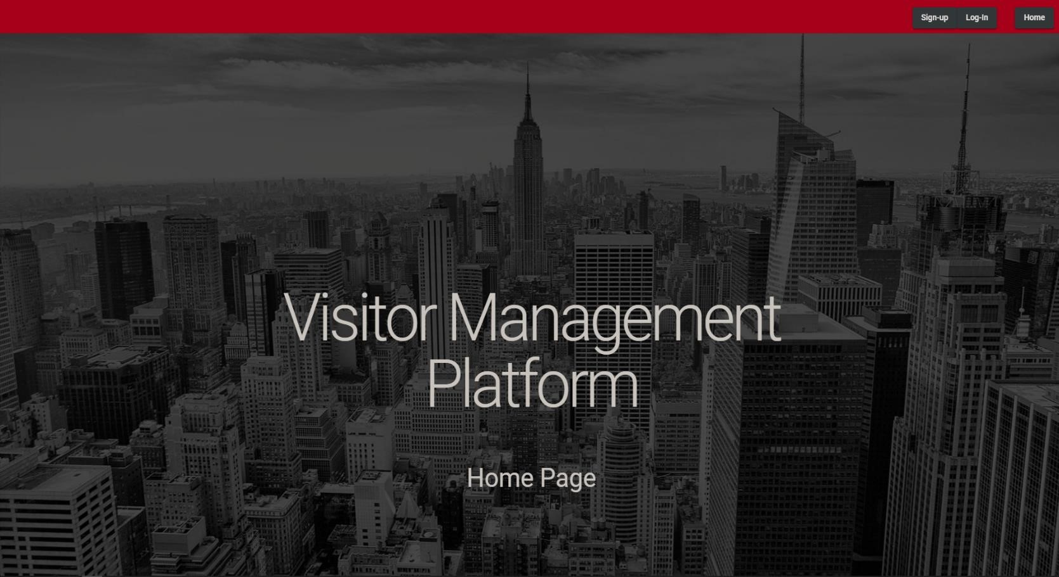

### EMPLOYEE LEVEL

Every user has different access levels. These are ‘employee’, ‘manager’ and ‘guard’. When you login to an employee account you can see the options of Log-Out, Home, Employee Home and Create

When you login the first thing you will see is all your entrys (ordered from latest to oldest) and your information displayed. You can click on your entrys to expand then to reveal more details and reveal the edit button.

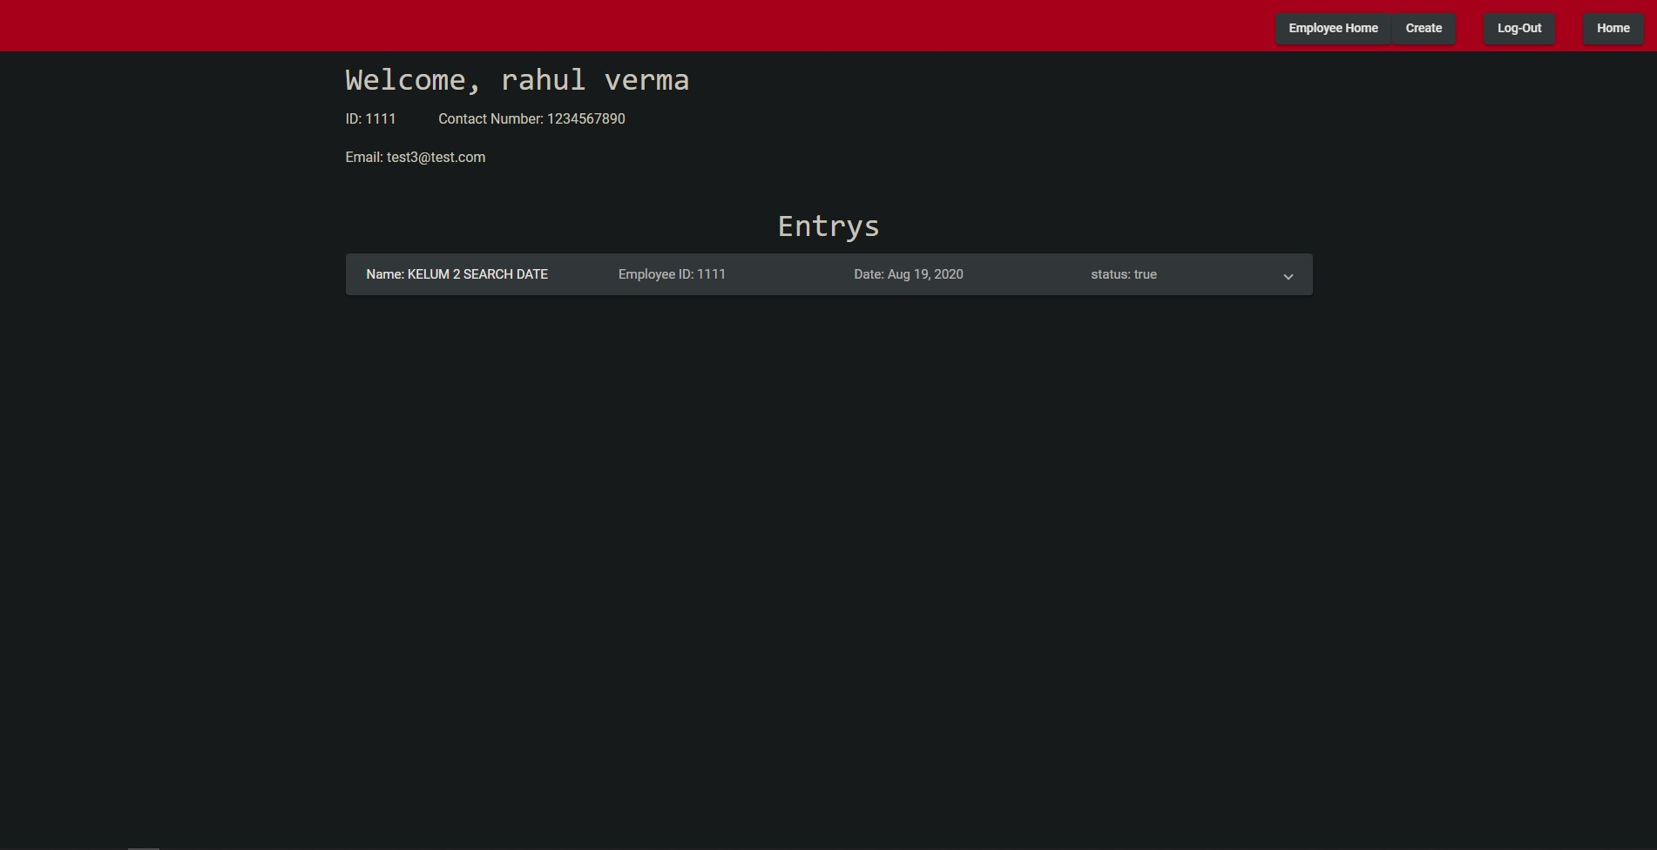

### EMPLOYEE LEVEL (Cont.)

You can use the ‘create’ button to create new entrys for your visitors.

The log-out button simply deletes your current session and you are transported back to the home screen

Pressing the home button will take you to the home page irrespective of the fact that you have or have not logged in, but if you have you would not need to sign back in because your account will be remembered

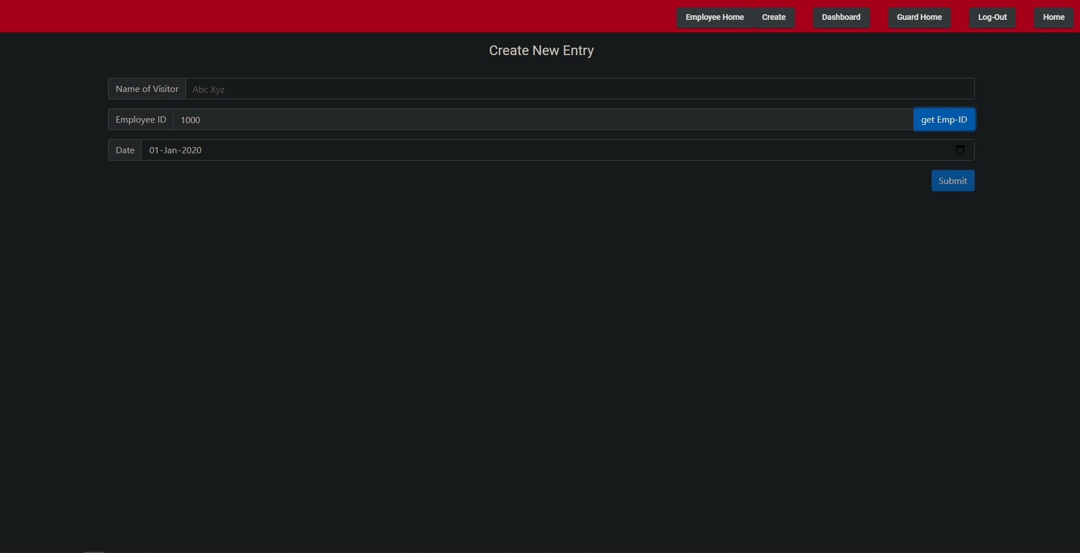

### GUARD LEVEL

As a Guard. When you login the first thing you will see is the guard dashboard and all the entrys (ordered from latest to oldest) will be valid for that day only.

When a new visitor approaches the guard, he can find that specific visitor’s entry by looking for the ‘add entry’ button. At the time of exit, the guard can click the ‘add exit’ button to add the exit time to the entry

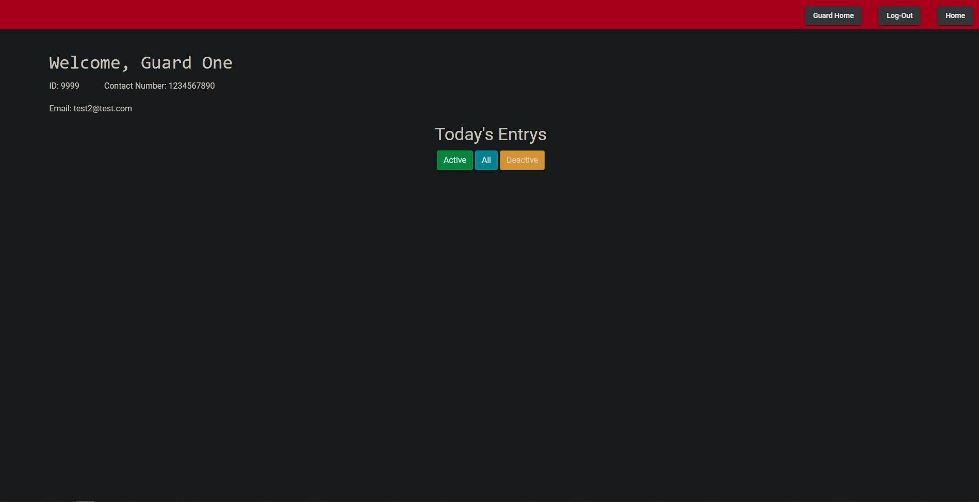

### MANAGER LEVEL

As a Manager. When you login the first thing you will see is the manager dashboard along with all the options of guards and employees.

Managers have an option to search a user by employee id and view all his entrys or see and delete entrys using a date

Managers are the only ones to have the option to delete Users

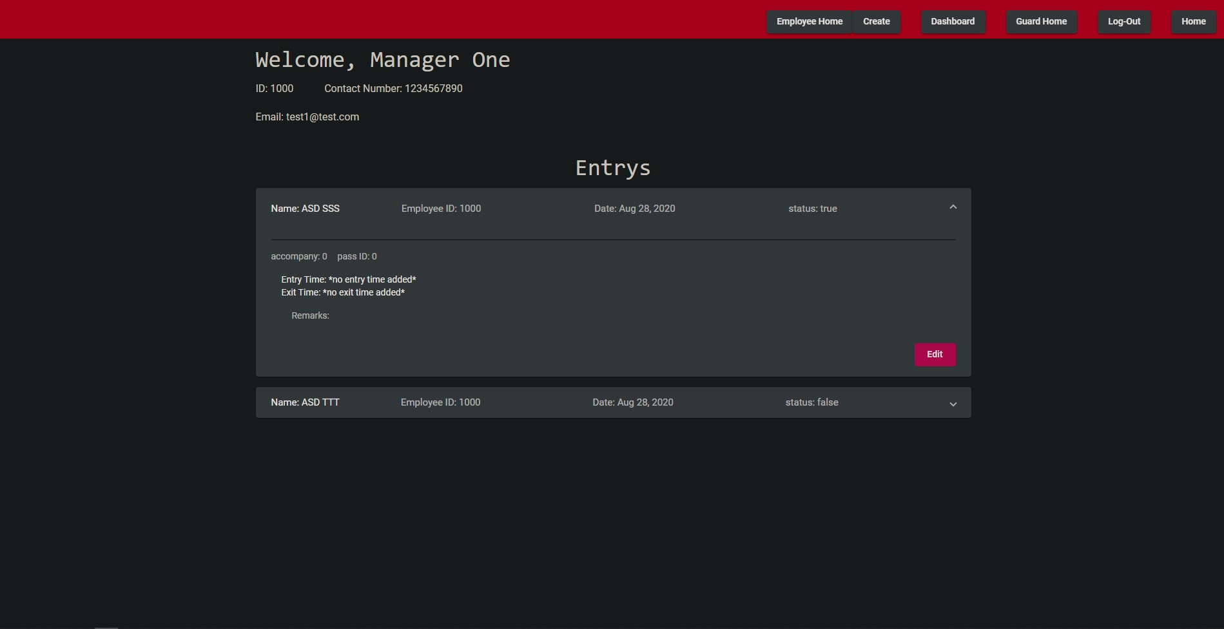

Conclusion

After the completion of the project, one can clearly say that our developed application will help small businesses and large enterprises in many ways to record the details and data of visitors and the users who create these entrys. This is the easy way to record the details manage them. It can use by any persons who has a browser and a web connection and who does not want to record the details of the visits on paper. Hence this reduces efforts and is a less time-consuming ordeal to perform.

Bibliography

* Questions asked on **:** [**https://stackoverflow.com/**](https://stackoverflow.com/)
* Tutorials for beginners : [**https://www.youtube.com/watch?v=vjf774RKrLc&t=1769s&ab_channel=DevEd**](https://www.youtube.com/watch?v=vjf774RKrLc&t=1769s&ab_channel=DevEd)
* MongoDB Documentation **:** [**https://docs.mongodb.com/**](https://docs.mongodb.com/)
* Angular Documentation : [**https://angular.io/docs**](https://angular.io/docs)
* NPM Package details : [**https://www.npmjs.com/**](https://www.npmjs.com/)
* Stylings Details : [**https://www.w3schools.com/html/**](https://www.w3schools.com/html/)
* Detailed step-by-step guides :[**https://medium.com/**](https://medium.com/)
* Bootstrap documentation for beautiful webpages : [**https://getbootstrap.com/docs/4.0/getting-started/introduction/**](https://getbootstrap.com/docs/4.0/getting-started/introduction/)